**TOPIC: Footwear Sales and Inventory System Database**

**TABLE OF CONTENTS**

**I. SAMPLE SCREENSHOT OF *INSERT YOUR SYSTEM HERE** .....................................2-4

**II. OBJECTIVES**…………………………………………………………………………………. 5

**III.ERD**…….......................................................................................................................... 5

**IV.RELATIONAL DATA MODEL**........................................................................................ 6

**V.TABLE STRUCTURE**...................................................................................................... 7-9

**VI. TABLE WITH SAMPLE DATA**......................................................................................10-13

**VII.QUERIES**....................................................................................................................... 14

1. QUERY-1..................................................................................................................14
2. QUERY-2..................................................................................................... ……….14
3. QUERY-3.................................................................................................................15
4. QUERY-4..........................................................................................................……15
5. QUERY-5................................................................................................................. 16
6. QUERY-6..........................................................................................................……16

**VIII. AGGREGATES**............................................................................................................ 17

1. COUNT.....................................................................................................................17
2. SUM..........................................................................................................................17
3. AVERAGE.................................................................................................................18

**IX. JOINING**.........................................................................................................................19

a. INNER JOIN...............................................................................................................19

b. LEFT JOIN.................................................................................................................19

c. RIGHT JOIN.............................................................................................................. 20

d. FULL JOIN................................................................................................................. 20

e. HYBRID JOIN………………………………………………………………………………. 21

**X. COMPLEX QUERIES** ......................................................................................................22

a. QUERY-1.................................................................................................................... 22

b. QUERY-2.....................................................................................................................22

c. QUERY-3.....................................................................................................................23

d. QUERY-4....................................................................................................................23

e. QUERY-5....................................................................................................................24

f. QUERY-6.....................................................................................................................24

**I. Sample screenshot of Footwear Database**

**Customer Table**

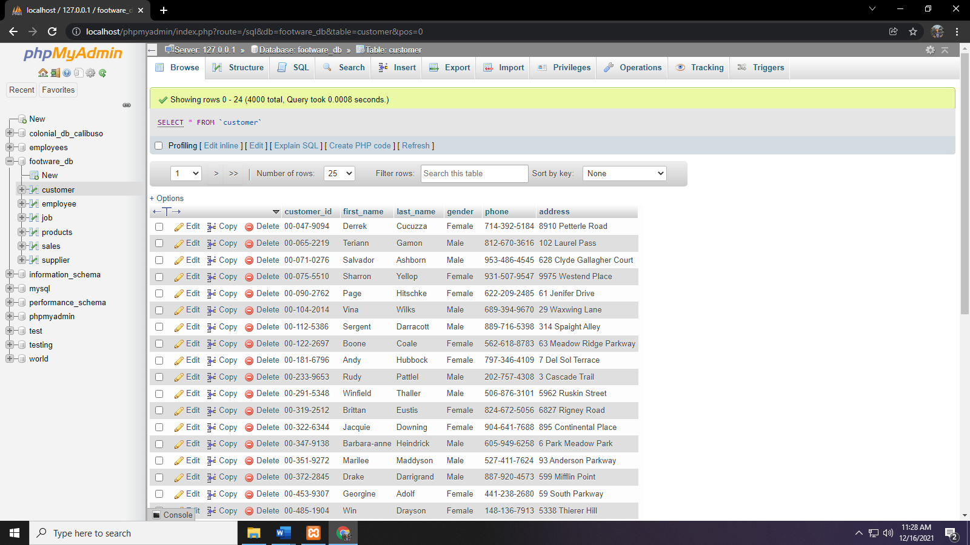

**Employee Table**

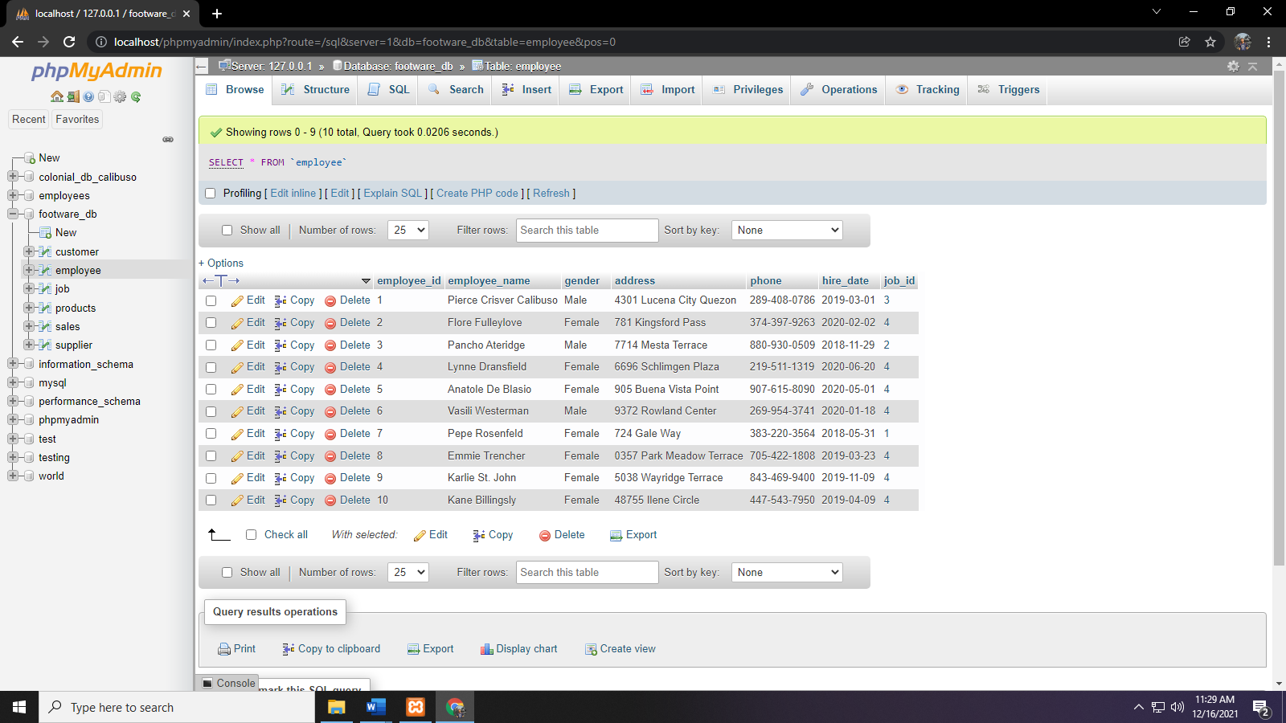

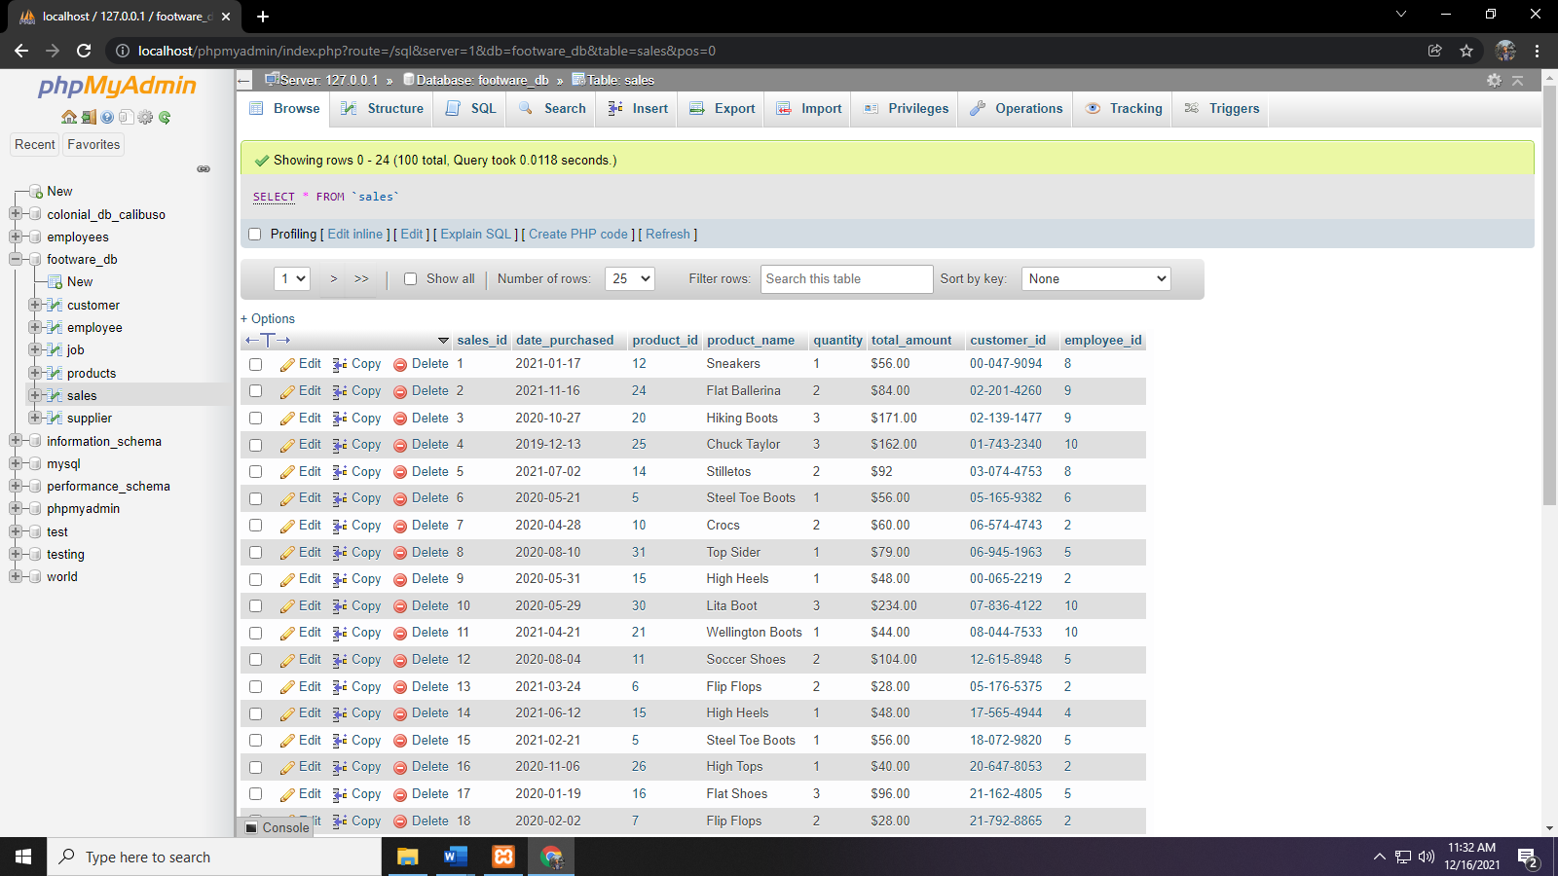**Sales Table**

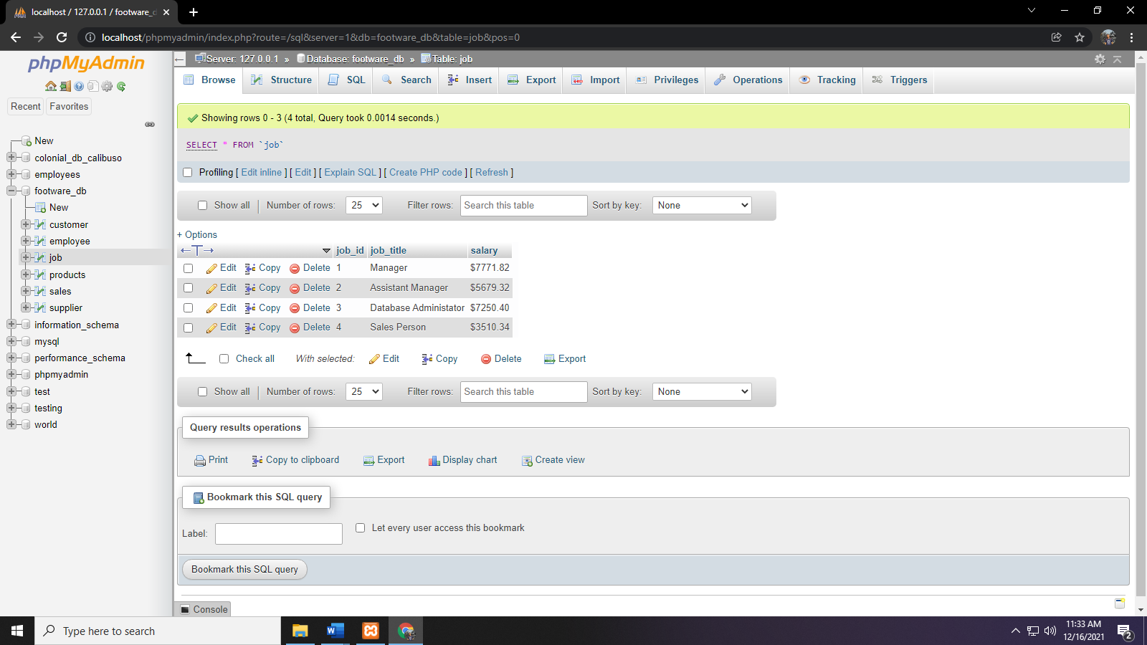**Job Table**

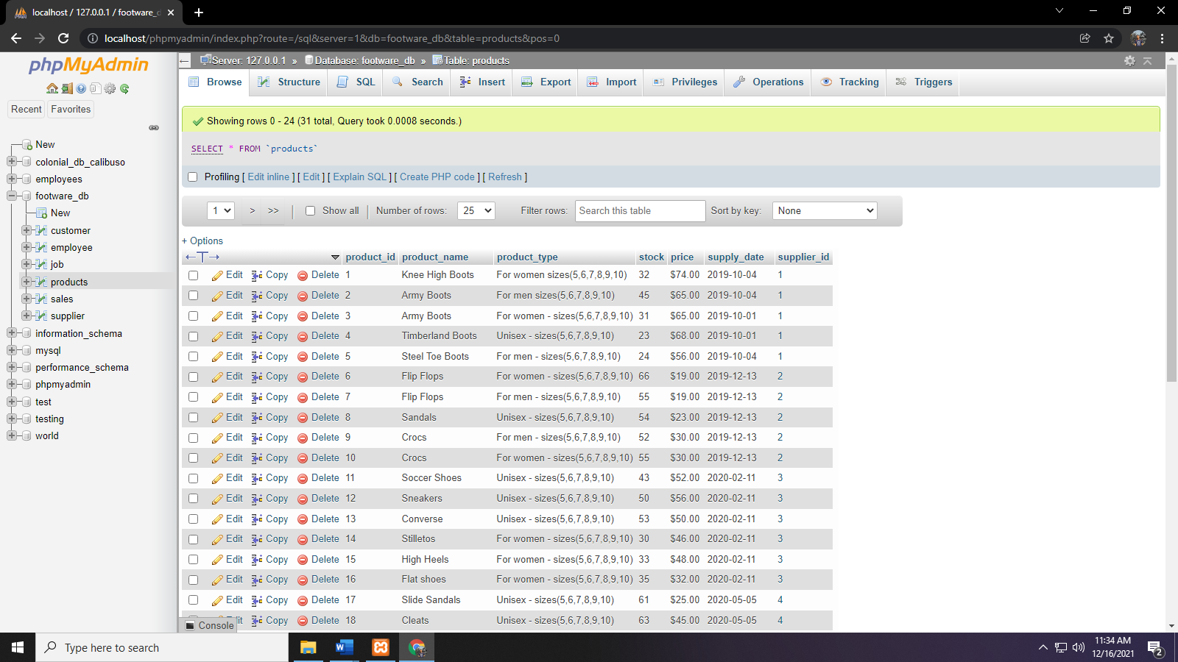**Products Table**

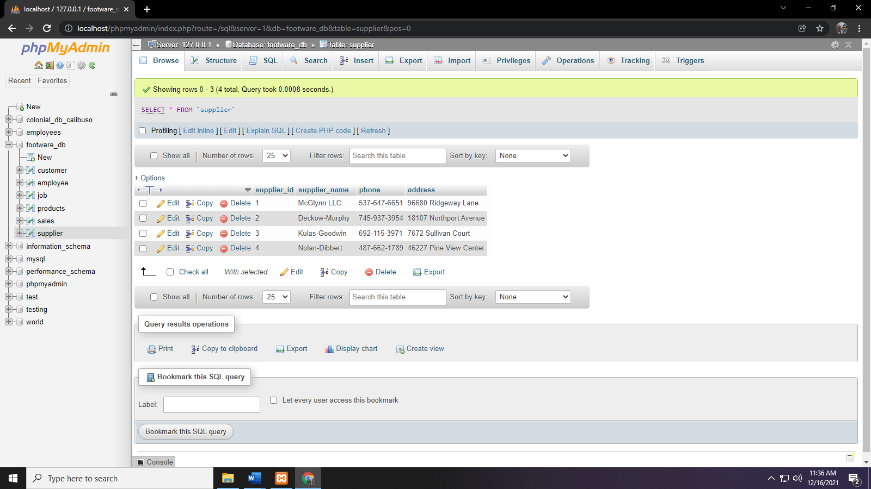**Supplier Table**

**II. OBJECTIVES:**

* The main objective of this project is to store a massive amount of data, organize it, and use it in future projects regarding footwear sales and inventory management.
* The efficient checking and managing of the products can support and help those who just manually want to track what is happening in the store especially the detailed information of a particular products such as stocks, prices and date supplied.
* This system also focuses on removing the redundant data caused by human errors such as duplication of data, data manipulation, inconsistency, etc.

**III.ERD**

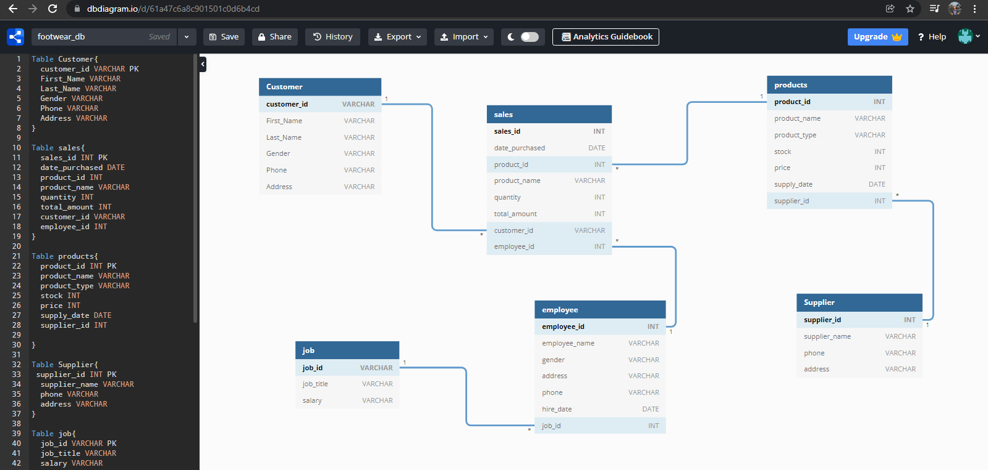

**IV.RELATIONAL DATA MODEL**

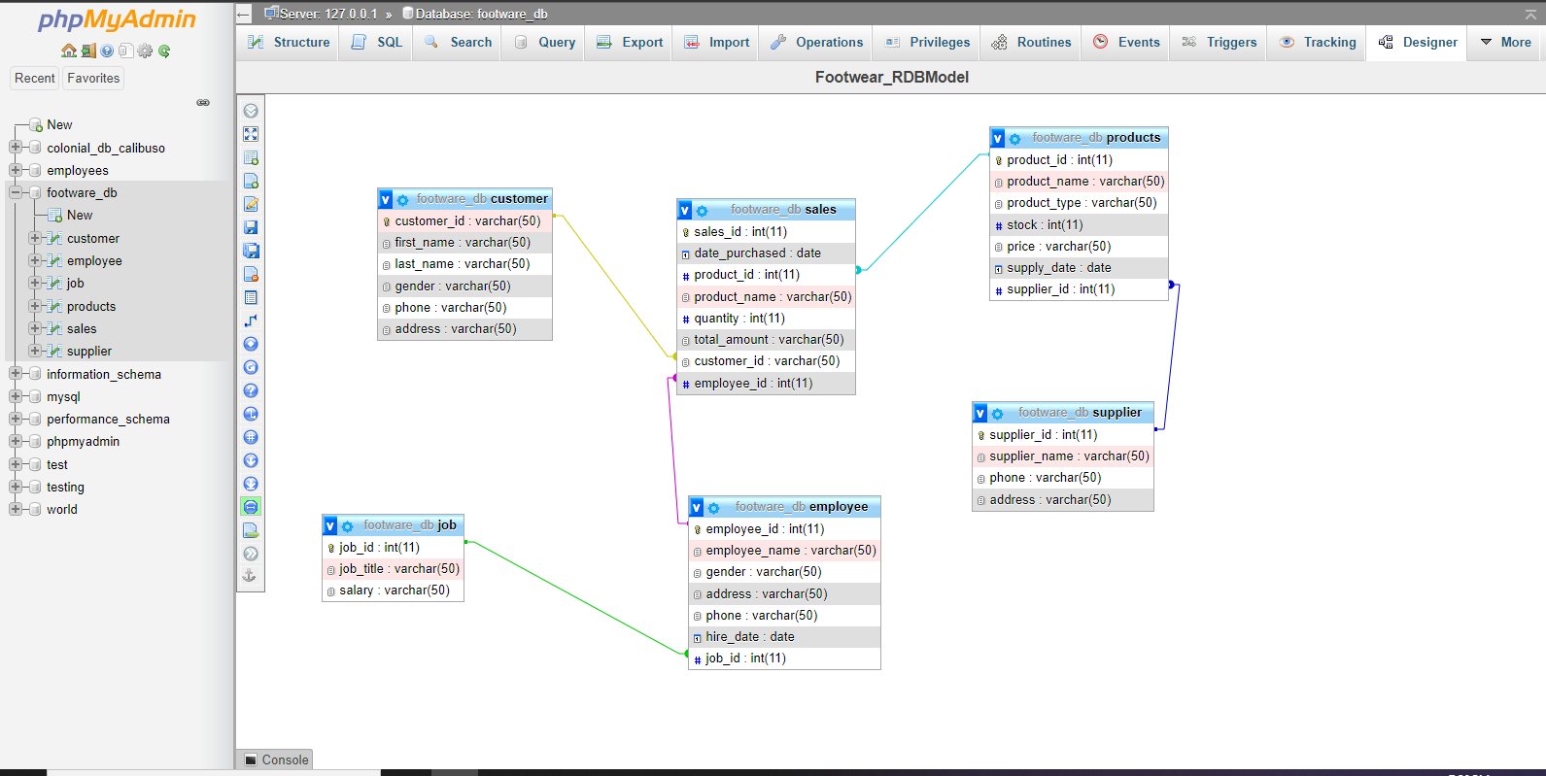

**V.TABLE STRUCTURE**

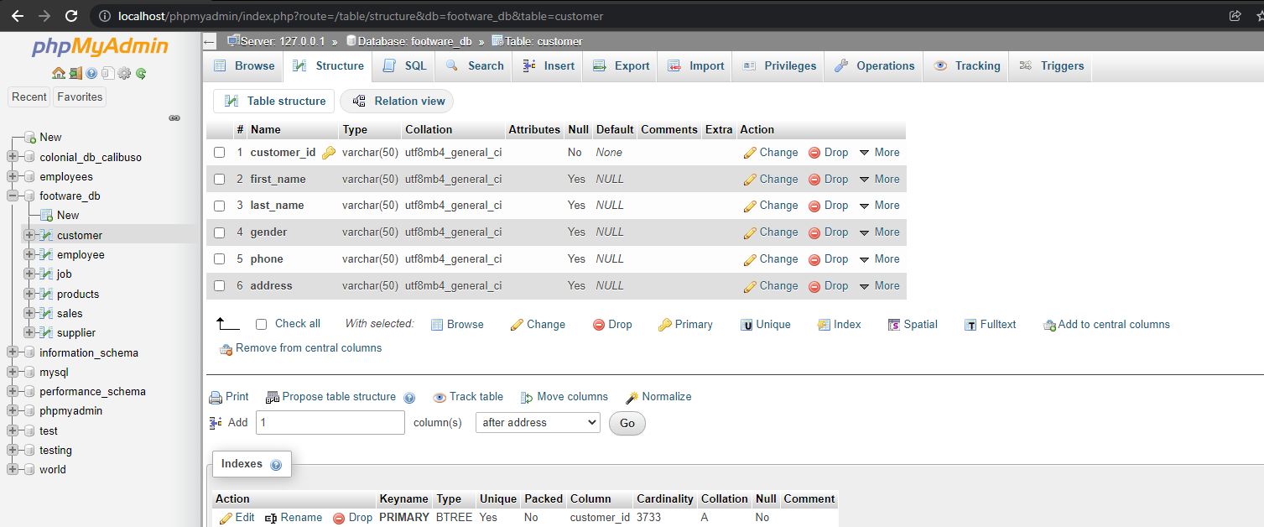**Customer Table Structure**

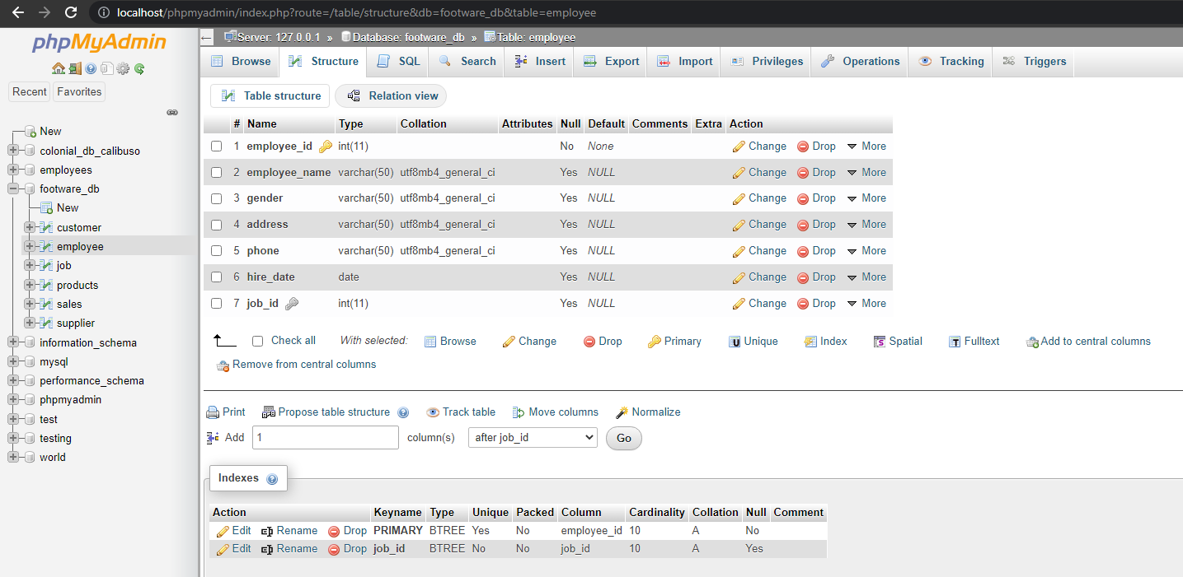**Employee Table Structure**

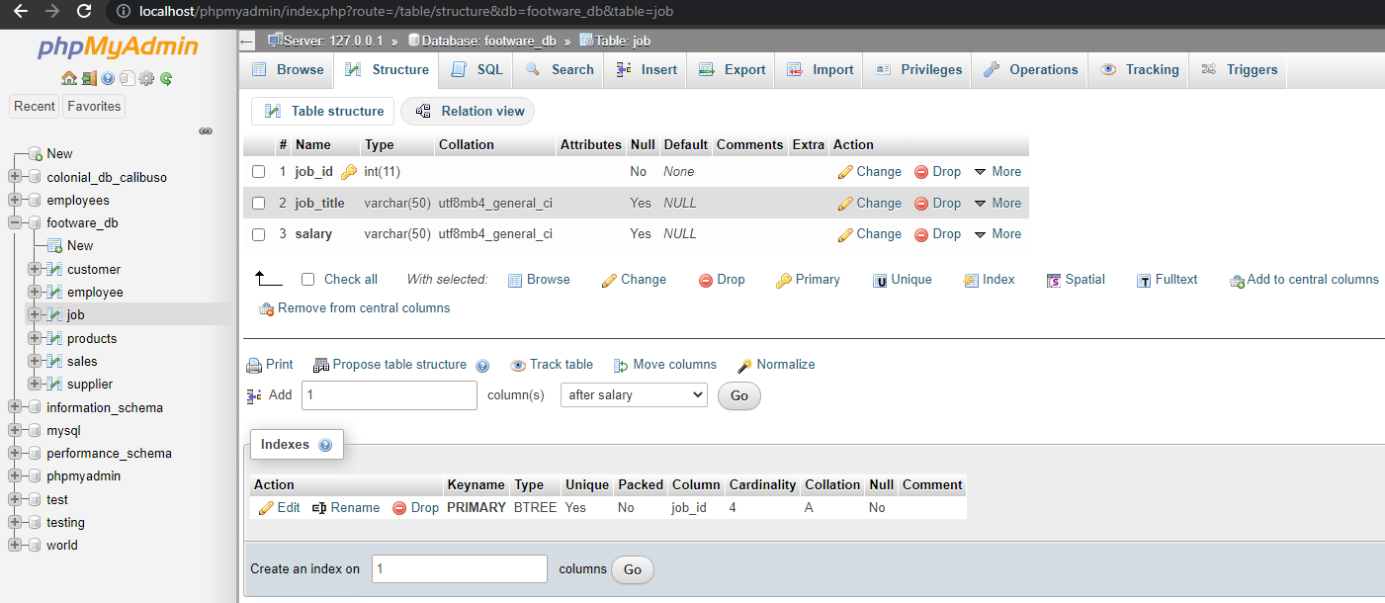**Job Table Structure**

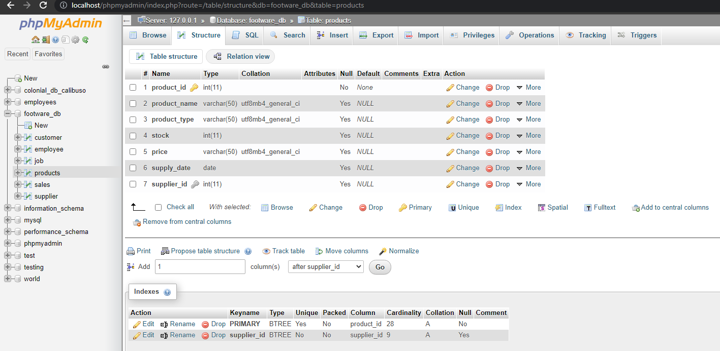**Products Table Structure**

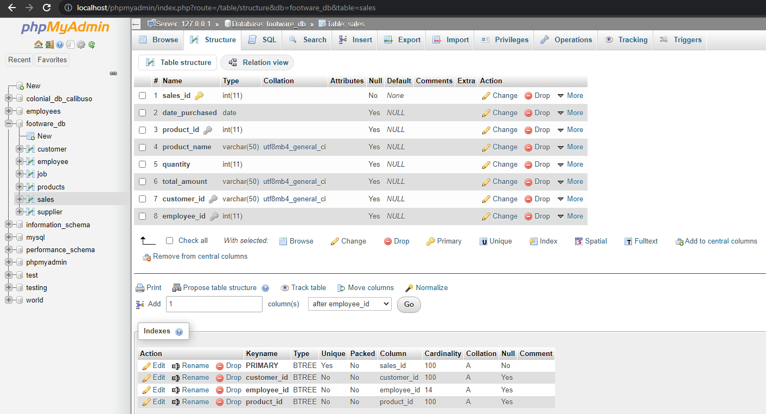**Sales Table Structure**

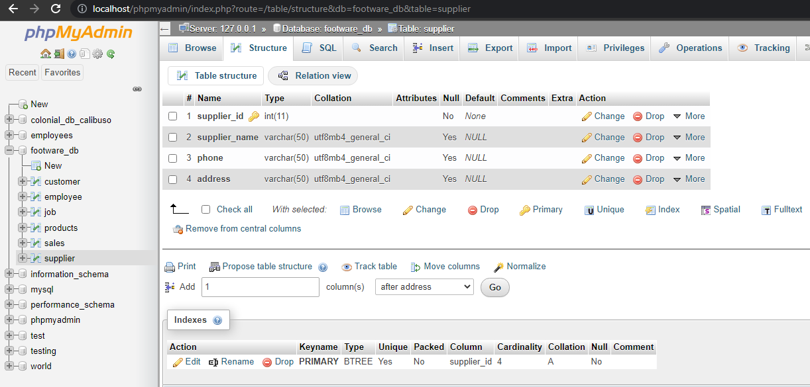**Supplier Table Structure**

**VI. TABLE WITH SAMPLE DATA**

**Customer Table**

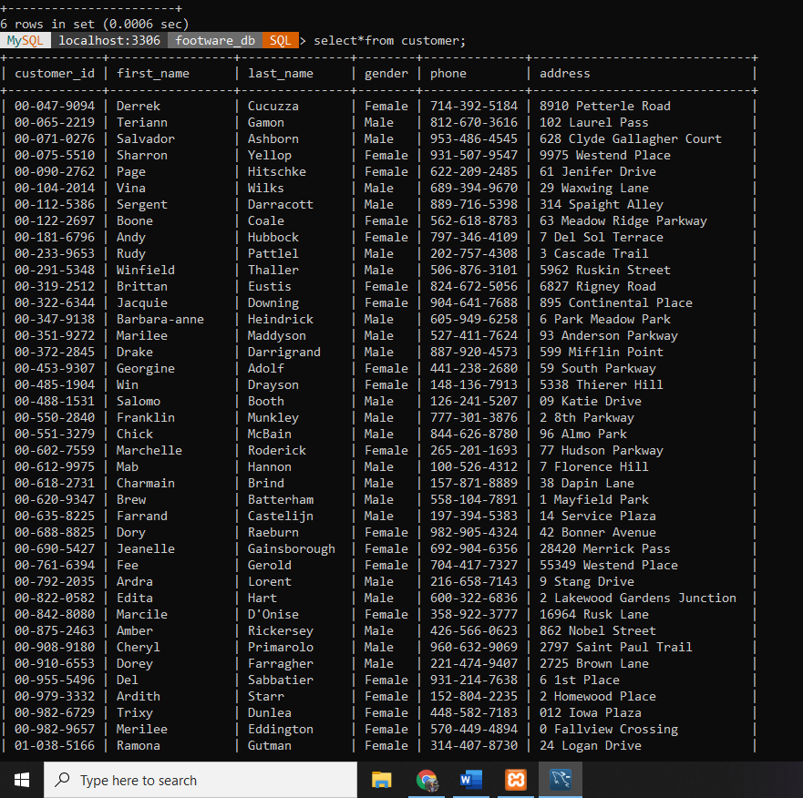

**Employee Table**

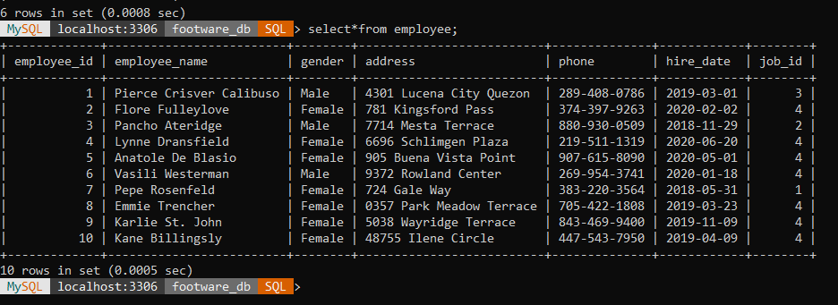

**Job Table**

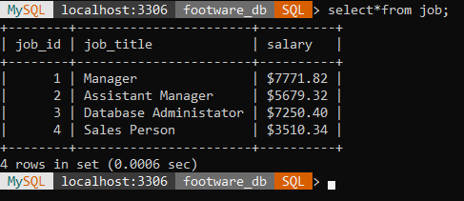

**Supplier Table**

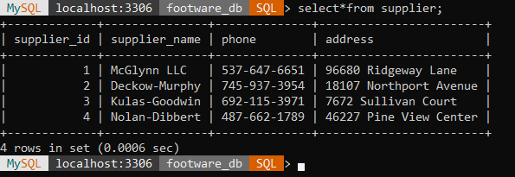

**Products Table**

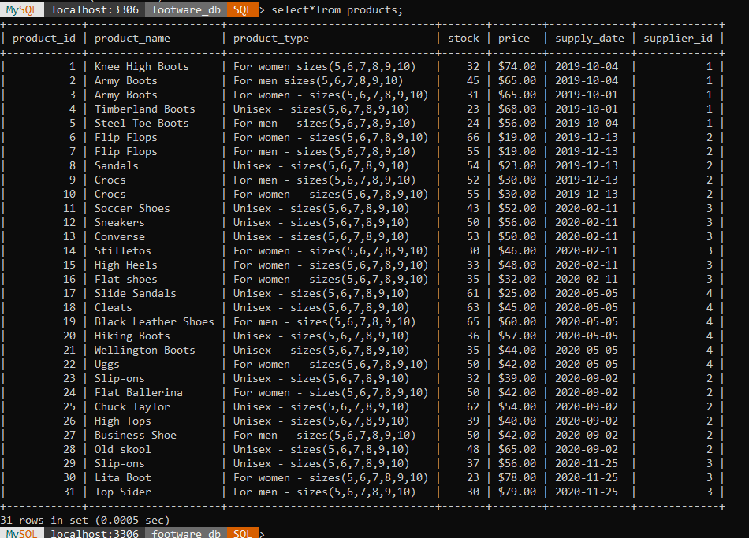

**Sales Table**

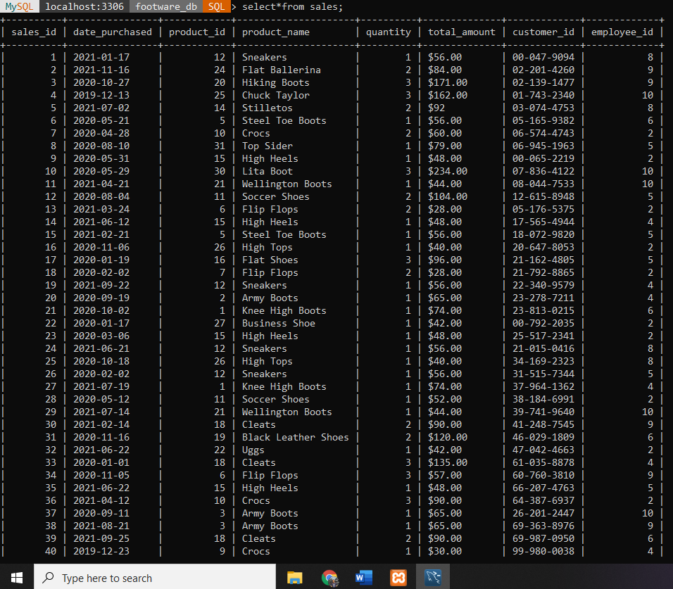

**VII. BASIC QUERIES**

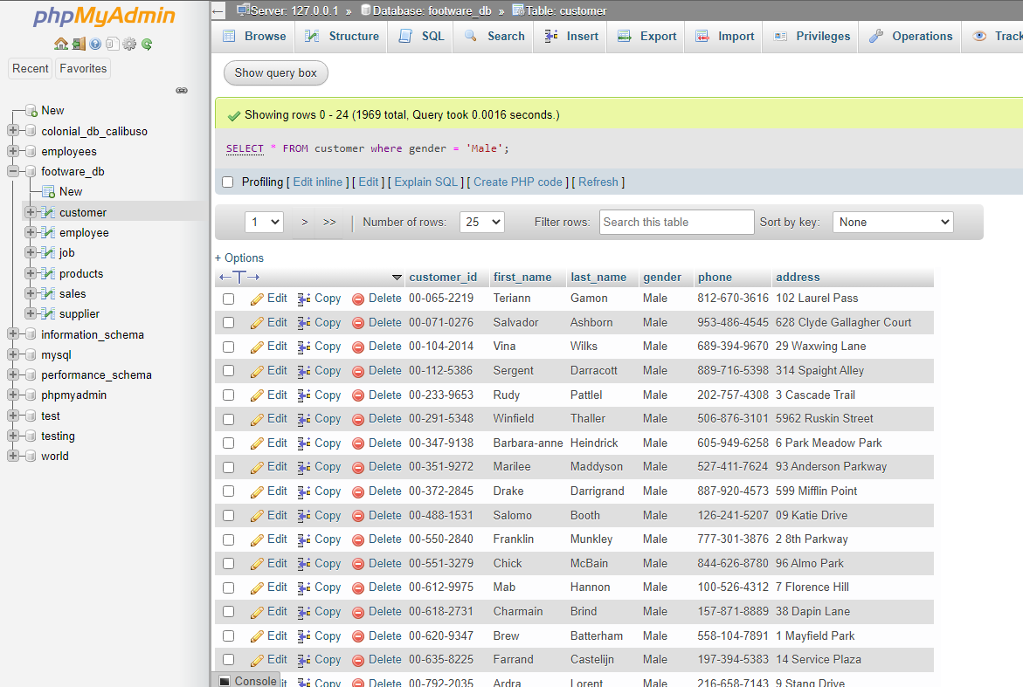**QUERY-1**

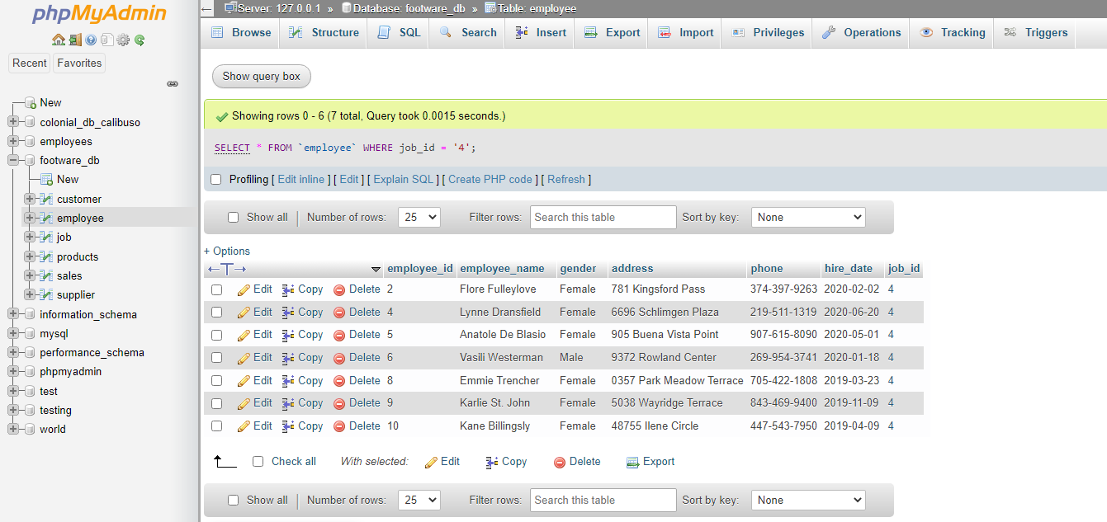**QUERY-2**

**QUERY-3**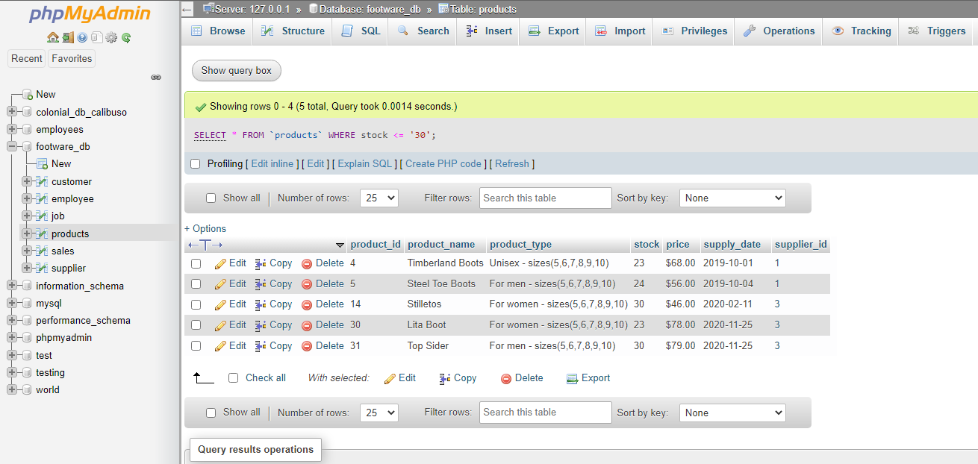

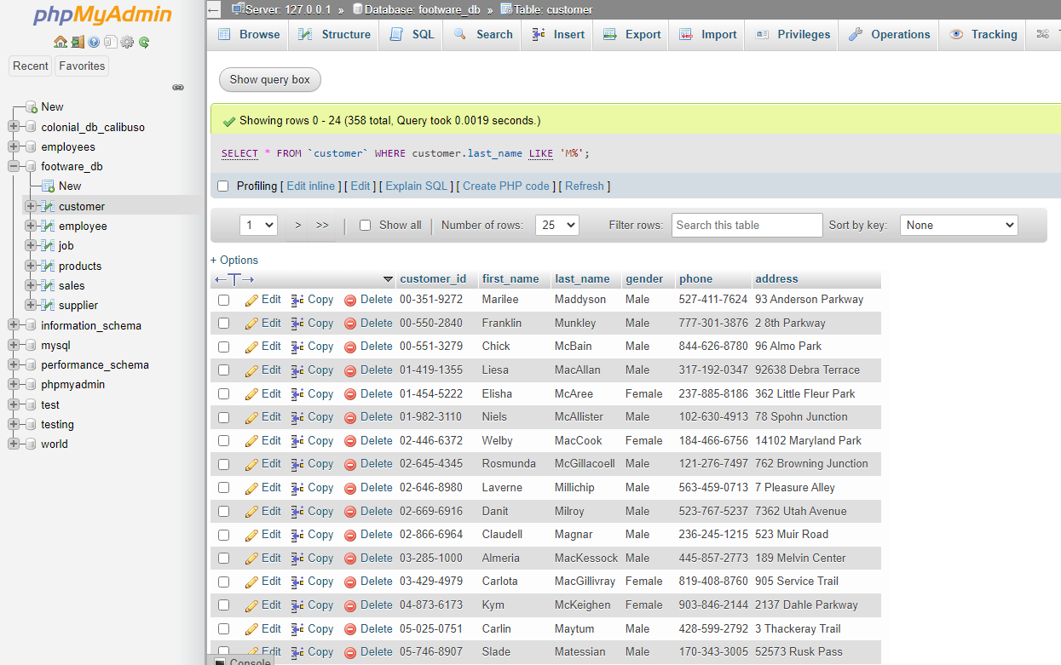**QUERY-4**

**QUERY-5**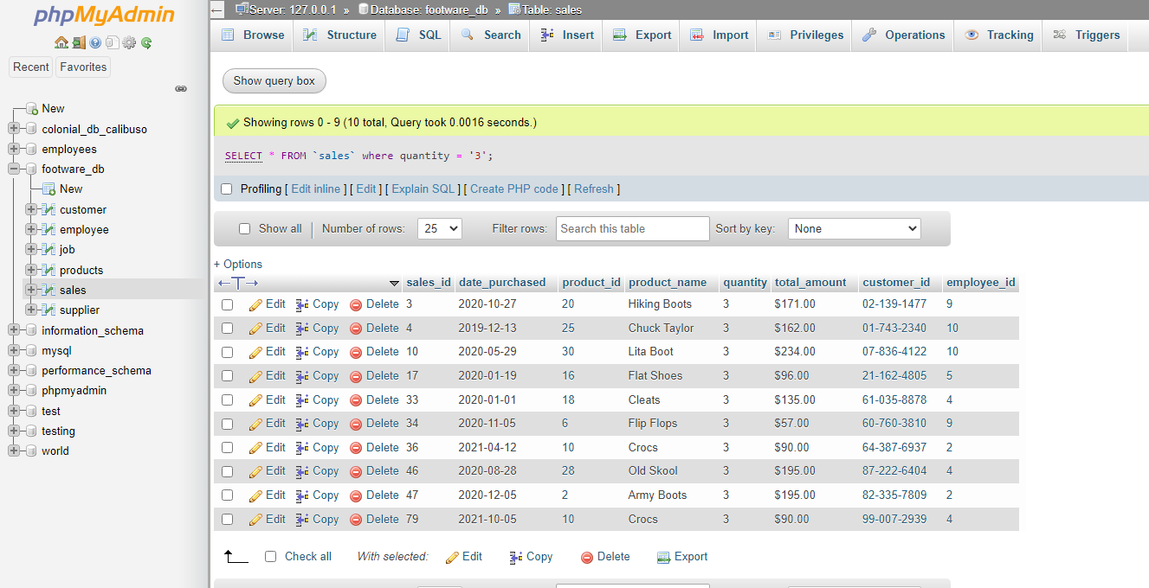

**QUERY-6**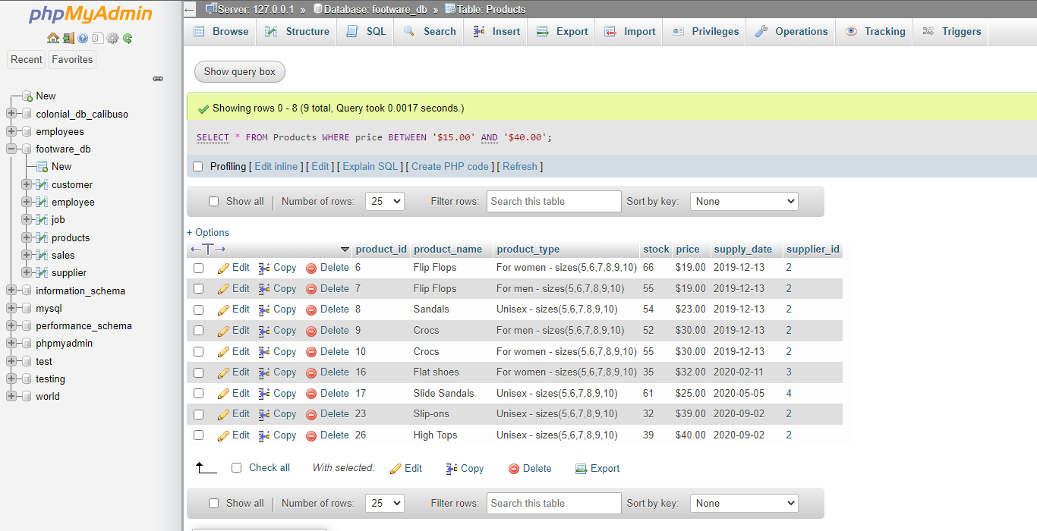

**VIII. AGGREGATES**

**Count**

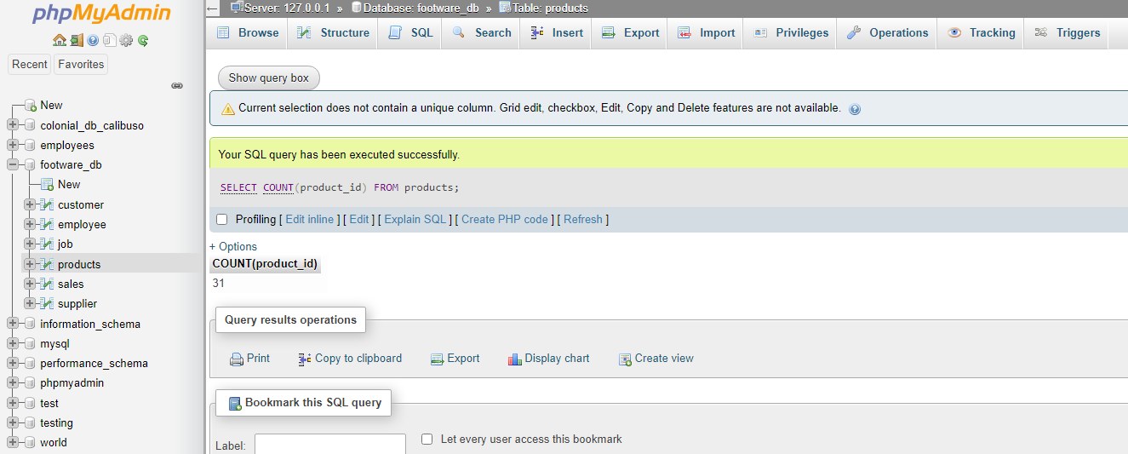

**Sum**

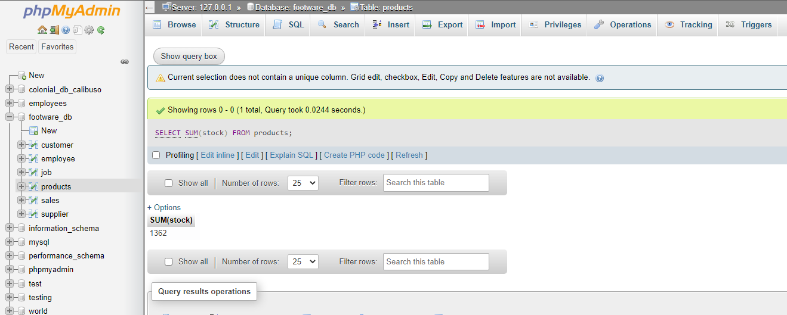

**Average**

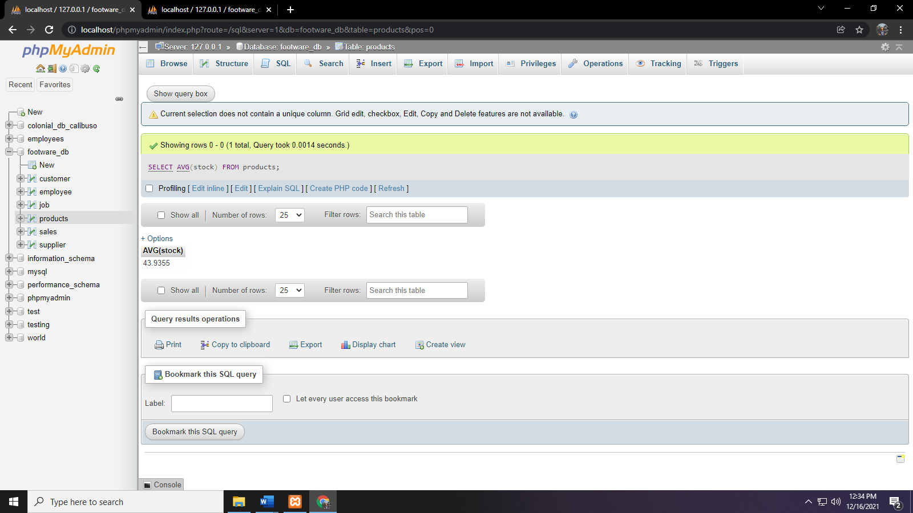

**IX. JOINING**

**INNER JOIN**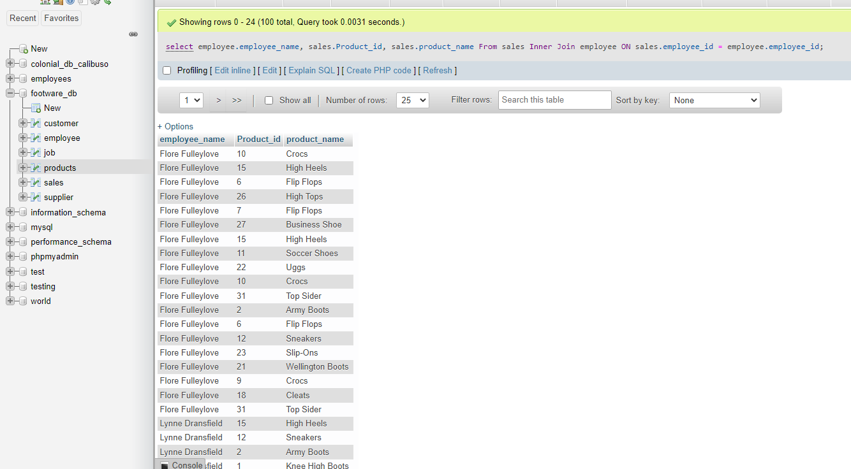

**LEFT JOIN**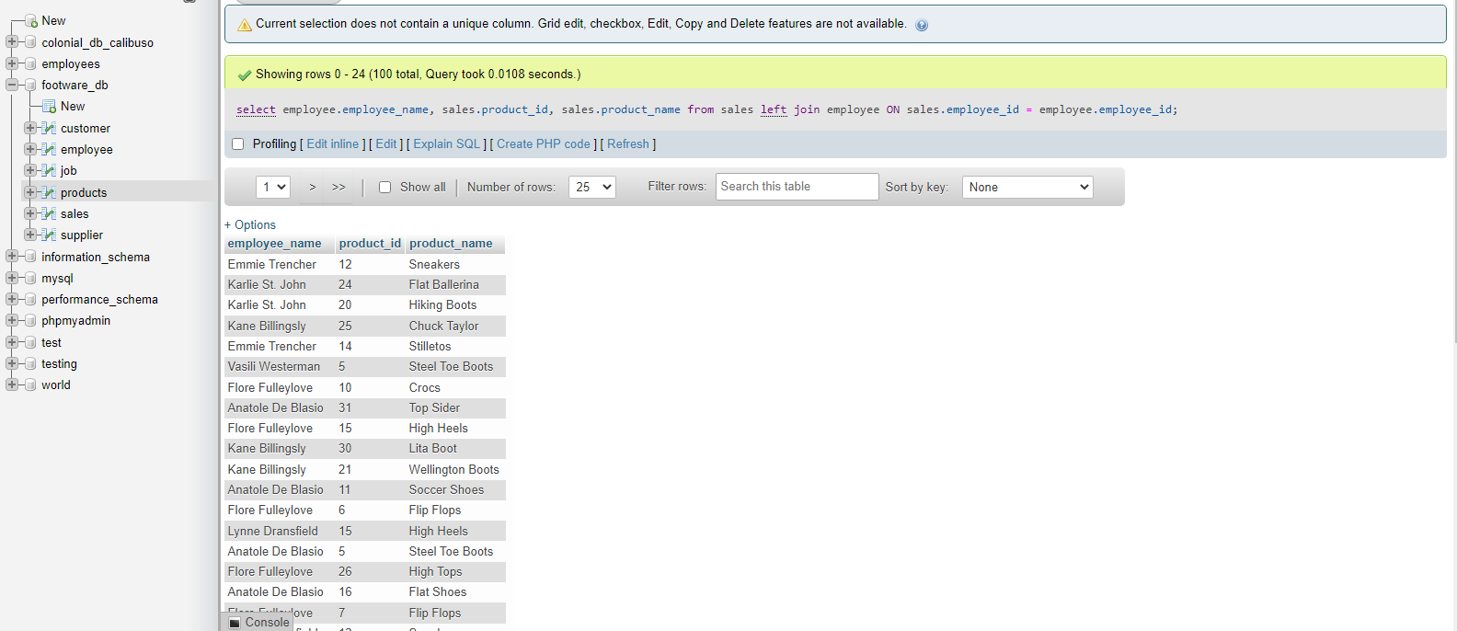

**RIGHT JOIN**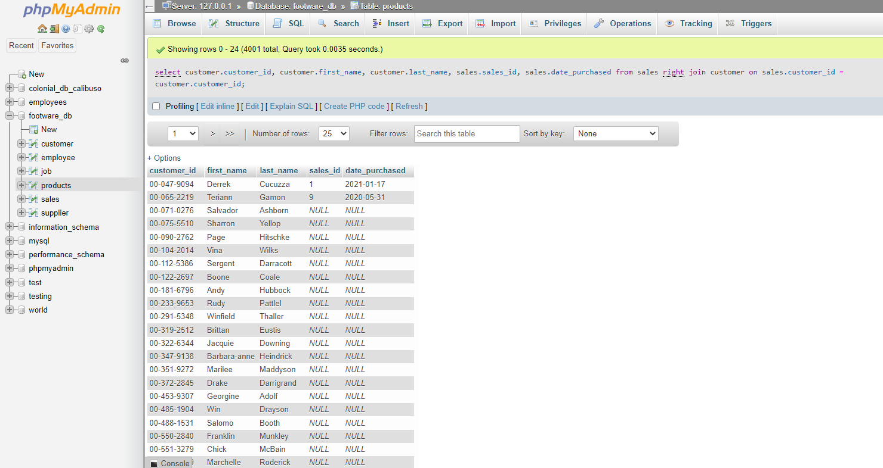

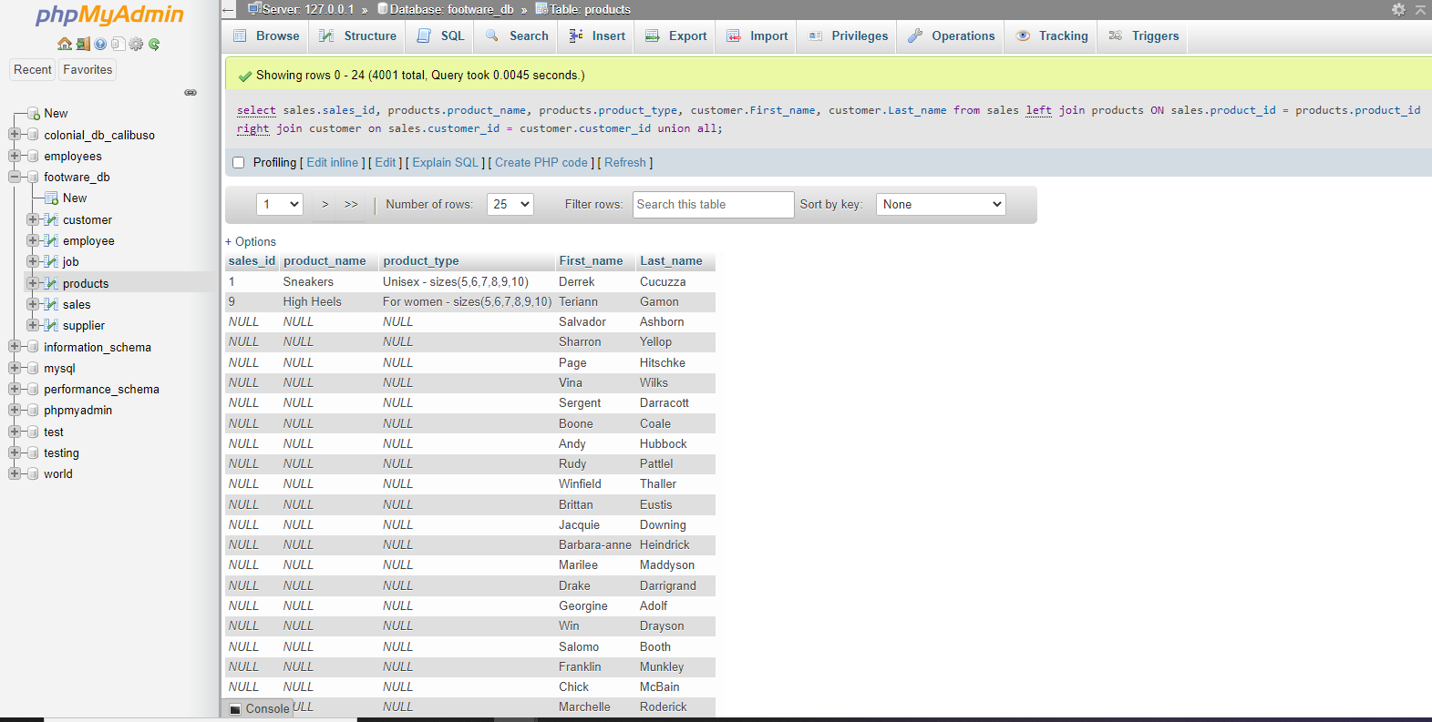**FULL JOIN**

**HYBRID JOIN**

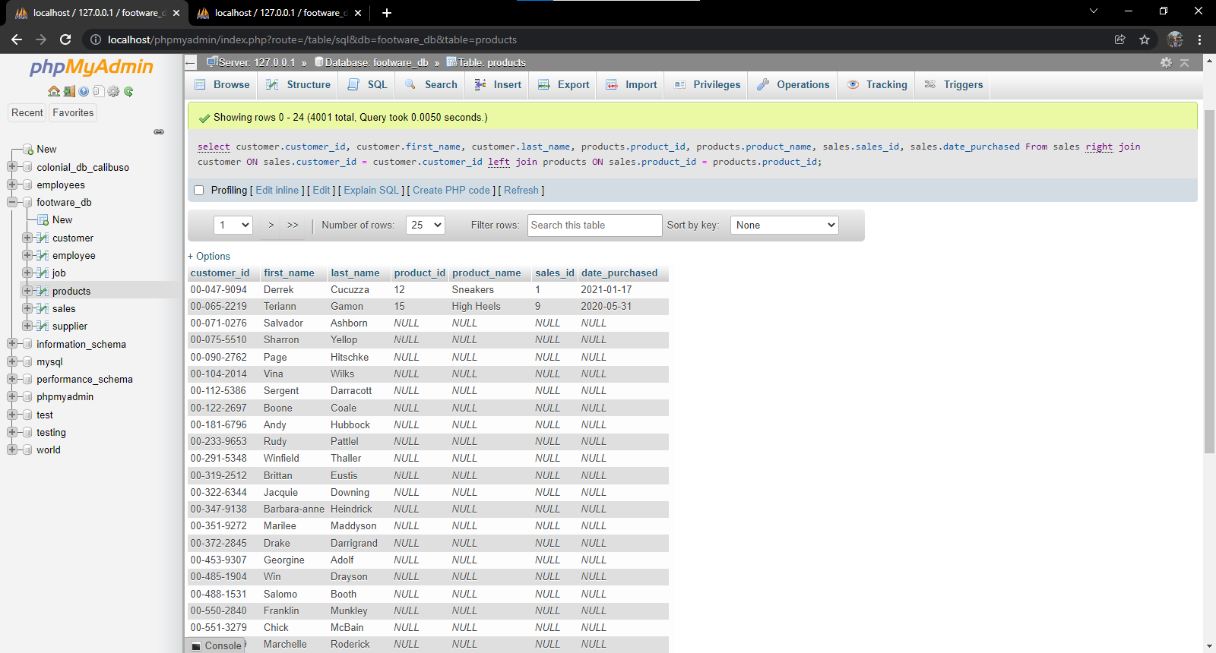

**X. COMPLEX QUERIES**

**QUERY-1**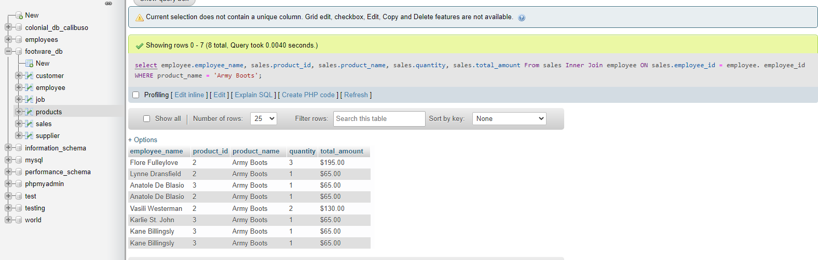

**QUERY-2**

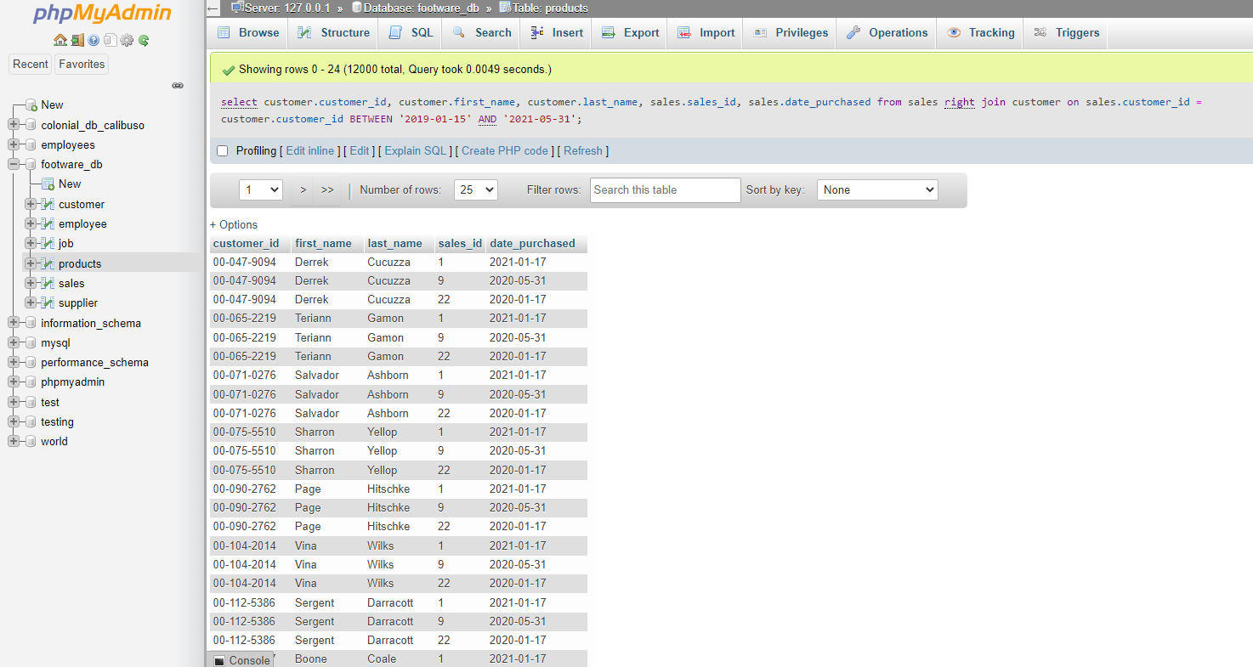

**QUERY-3**

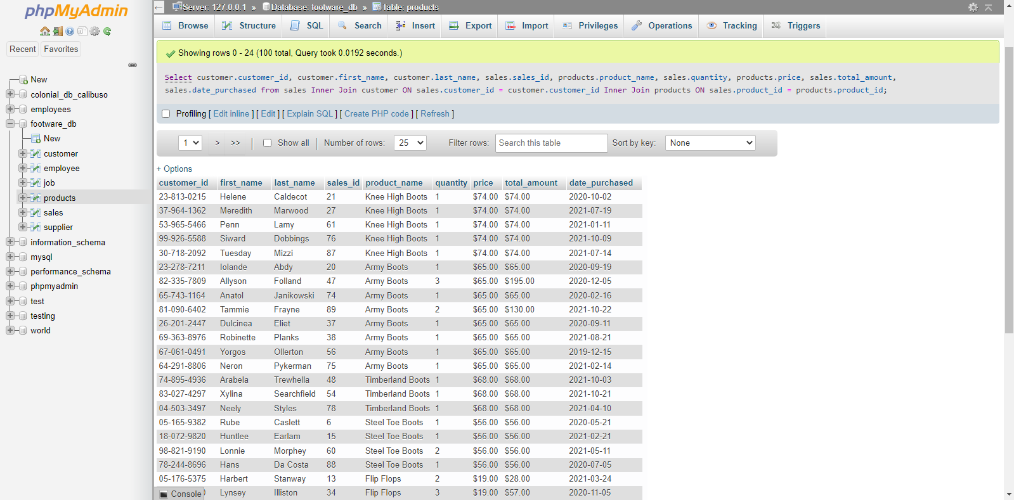

**QUERY-4**

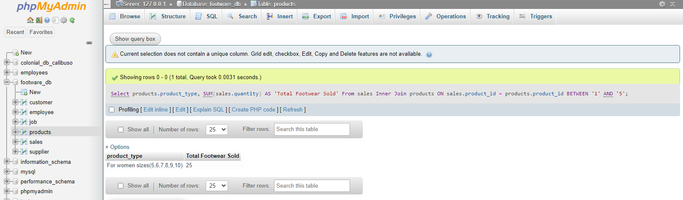

**QUERY-5**

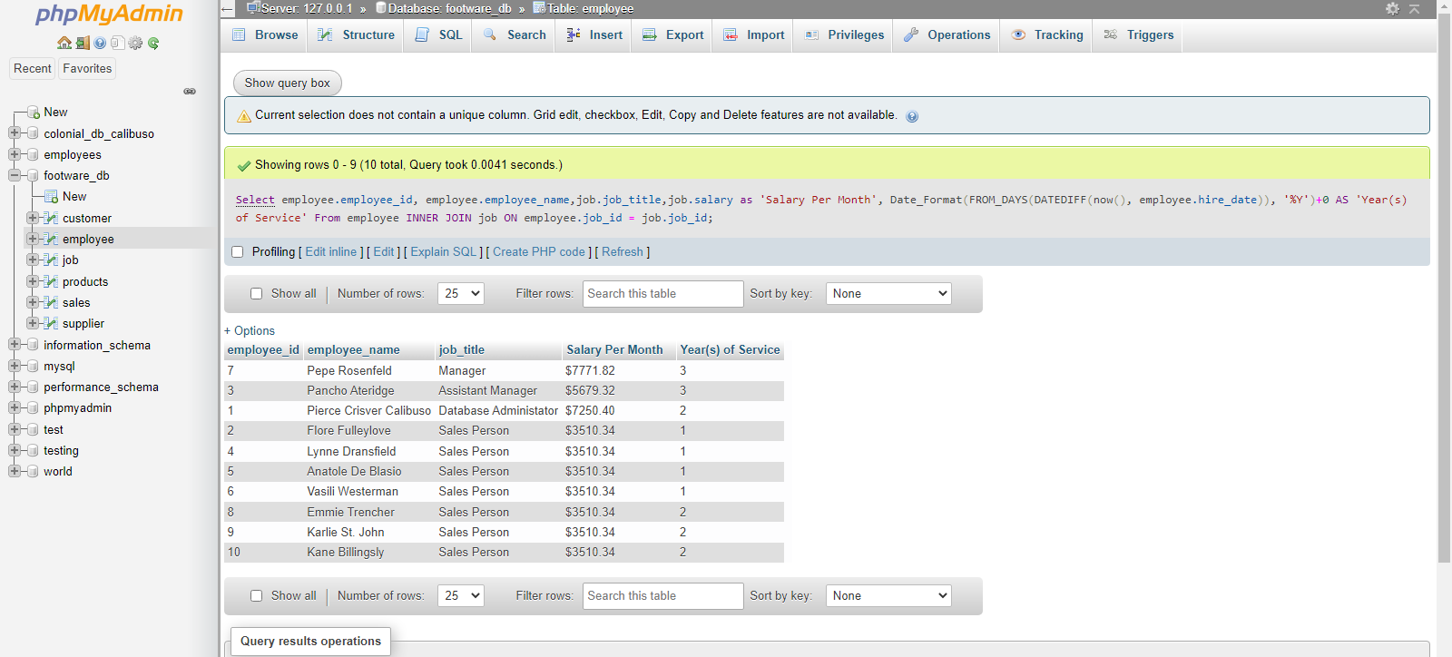

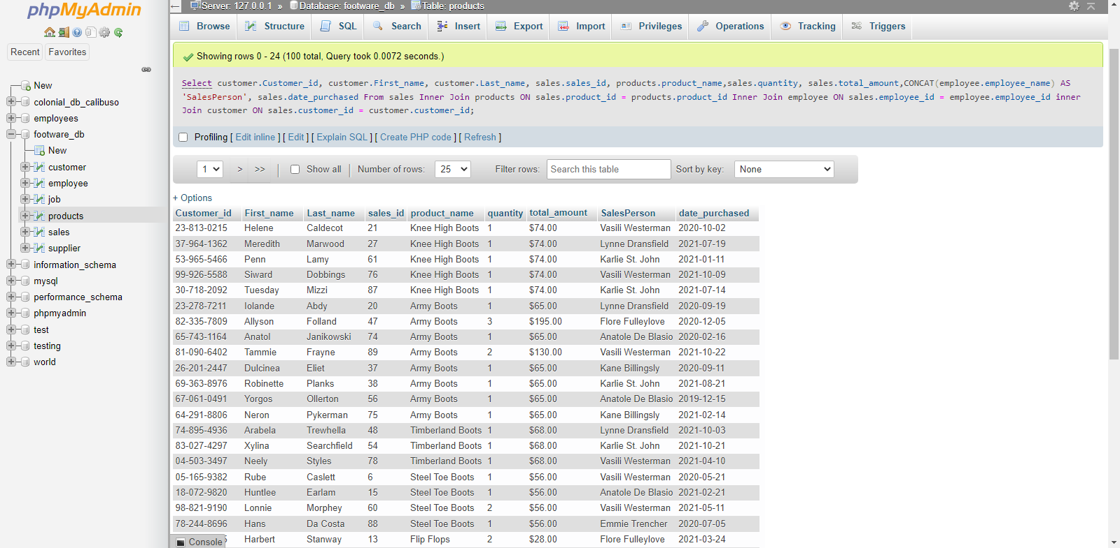**QUERY-6**